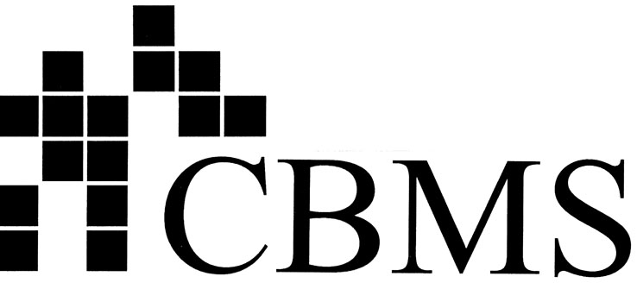  CONFERENCE BOARD OF THE MATHEMATICAL SCIENCES  1529 Eighteenth Street NW, Washington DC 20036 |  | rosier@georgetown.edu  kolbe.lisa@gmail.com  www.cbmsweb.org

Collective Effort to Improve the First Two Years of College Math
Statement by Presidents of CBMS Member Professional Societies

In a major cooperative effort to improve mathematics learning in the critical first two years of college, five mathematical sciences professional societies (AMS, AMATYC, ASA, MAA, and SIAM) have joined forces to address a wide range of issues that affect the first two years of collegiate mathematics. The efforts are broadly directed toward students with a wide range of college and career aspirations and they reflect a powerful collective effort rather than an attempt to make one size fit all. To help develop broad based support, this work is being done in consultation with teacher and K-12 educators’ organizations.
Many of the key issues being addressed have been highlighted in reports such as PCAST’s Engage to Excel and the National Academies’ The Mathematical Sciences in 2025 (Math 2025). Although many of the programs were underway prior to these reports, they can be viewed as part of the constructive response by the mathematical community to these reports and to the impact of the ongoing implementation of Common Core State Standards. Collectively they address the needs to adjust curriculum design, pedagogical approaches and preparation for changing workforce demands and expectations. They also address professional development to help college faculty prepare for the important challenges, both those that are long standing and those that emerge from proposed responses.
This collective action is exemplified by a number of collaborative projects (primary partners in parentheses):
- Common Vision for Undergraduate Mathematics in 2025 (MAA-AMATYC-AMS-ASA-SIAM)
- Transforming Post-Secondary Education in Mathematics, TPSE Math (AMS-MAA-SIAM)
- Modeling across the Curriculum, MaC (SIAM-ASA-MAA)
- Preparation for Industrial Careers in Mathematics, PIC-Math (MAA-SIAM)
- Investing in the Next Generation through Innovative and Outstanding Strategies, INGenIOuS (MAA-ASA-AMS-SIAM)
- Guidelines for Assessment and Instruction in Statistics Education GAISE (ASA but also being used collaboratively with SIAM in developing an analogous Mathematical Modeling, GAIMME report)
These various initiatives were all among those featured at the recent CBMS Forum on the First Two Years of College Math: Building Student Success (October 2014). Like the Forum, the listed projects have all been generously funded by public and private foundations including the National Science Foundation. Taken together these different but complementary projects represent a concerted collective approach to issues of mathematics education during the critical transition from high school through the first two years of college.

We, the undersigned CBMS member society presidents, express our support for the efforts of these professional societies and we encourage the continuation and expansion of these initiatives in consultation with the teacher educator and K-12 communities.

Nancy Sattler
American Mathematical Association
of Two Year Colleges

Robert Bryant
American Mathematical Society

David Morganstein
American Statistical Association

Alasdair Urquhart
Association for Symbolic Logic

Ruth Charney
Association for Women in Mathematics

Fran Arbaugh
Association of Mathematics Teacher Educators

Diana Suddreth
Association of State Supervisors of Mathematics

Vanessa Cleaver
Benjamin Banneker Association

Robert Devaney
Mathematical Association of America

Edray Goins
National Association of Mathematicians

Valerie Mills
National Council of Supervisors of Mathematics

Diane Briars
National Council of Teachers of Mathematics

Pam Cook
Society for Industrial and Applied Mathematics

Susie Hakansson
TODOS: Mathematics for ALL

